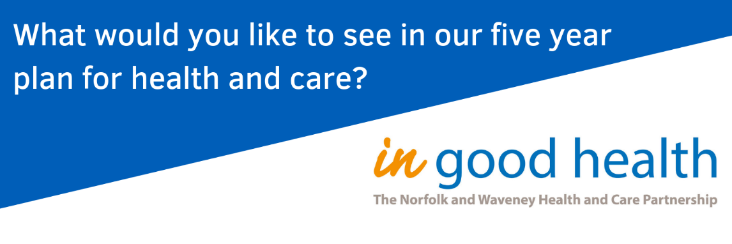
Making Norfolk and Waveney a healthier place to live

We all have lots of experiences of caring for others, and being cared for.
Could you turn your experiences into good ideas about how we can improve the health and wellbeing of people living in Norfolk and Waveney?
Your local NHS and care organisations are working together to plan for the future.
Join our online conversation to share your ideas and see other people’s suggestions:
https://ingoodhealth.dialogue-app.com/
Your ideas might just save a life, so get involved and tell us what you want to see in our five year plan for health and care.
Making Norfolk and Waveney a healthier place to live

We all have lots of experiences of caring for others, and being cared for.
Could you turn your experiences into good ideas about how we can improve the health and wellbeing of people living in Norfolk and Waveney?
Your local NHS and care organisations are working together to plan for the future.
Join our online conversation to share your ideas and see other people’s suggestions:
https://ingoodhealth.dialogue-app.com/
Your ideas might just save a life, so get involved and tell us what you want to see in our five year plan for health and care.

